**Hands-on Day-1 Sai Kumaravelu A.T.**

**916531**

**1) TypeScript data types and interface – Define Employee interface and display**

**Employee.ts**

export interface Employee {

id:number;

name:string;

salary:number;

permanent:boolean;

}

**Employee-test.ts**

import { Employee } from './Employee';

var emp:Employee = {

id:3,

name:"John",

salary:5000,

permanent:true,

}

console.log("id : "+emp.id);

console.log("name : "+emp.name);

console.log("salary : "+emp.salary);

console.log("permanent : "+emp.permanent);

**OUTPUT:**

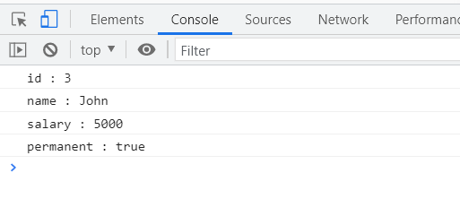

**2) TypeScript data types and interface – Include Department details in Employee and display**

**Department.ts**

export interface Department{

id:number;

name:string;

}

**Employee.ts**

import { Department } from './Department';

export class Employee implements Department{

id:number;

name:string;

salary:number;

permanent:boolean;

constructor(id:number, name:string, salary:number, permanent:boolean){

this.id = id;

this.name = name;

this.salary = salary;

this.permanent = permanent;

}

}

Employee-test.ts

import { Department } from './Department';

import { Employee } from './Employee';

var emp1 = new Employee(123, "John", 5000, true);

console.log("id: "+emp1.id);

console.log("name: "+emp1.name);

console.log("salary: "+emp1.salary);

console.log("permanent: "+emp1.permanent);

var dept:Department = {

id:1,

name:"Payroll",

}

console.log("Department id : "+dept.id);

console.log("Department name : "+dept.name);

**OUTPUT:**

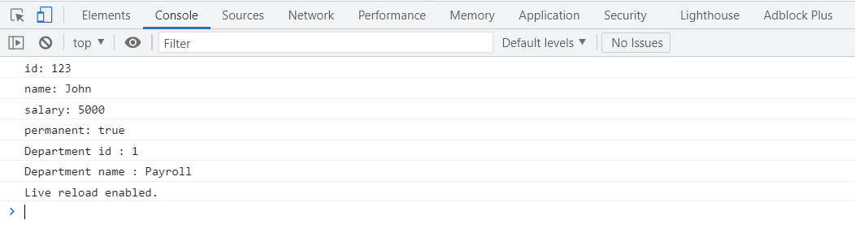

**3) TypeScript data types and interface – Define Employee interface and display**

**Department.ts**

export interface Department{

id:number;

name:string;

}

**Skill.ts**

export interface Skill{

id:number;

name:string;

}

**Employee.ts**

import { Employee } from './Employee';

import { Skill } from './Skill';

import { Department } from './Department';

var emp1 = new Employee(123, "John", 10000, true);

console.log("id: "+emp1.id);

console.log("name: "+emp1.name);

console.log("salary: "+emp1.salary);

console.log("permanent: "+emp1.permanent);

var dept:Department = {

id:1,

name:"Payroll",

}

console.log("Department id : "+dept.id);

console.log("Department name : "+dept.name);

var skill1:Skill = {

id:1,

name:"HTML",

}

var skill2:Skill = {

id:2,

name:"CSS",

}

var skill3:Skill = {

id:3,

name:"JavaScript",

}

console.log("Skill[0]:"+skill1.id+", "+skill1.name);

console.log("Skill[1]:"+skill2.id+", "+skill2.name);

console.log("Skill[2]:"+skill3.id+", "+skill3.name);

Employee-test.ts

import { Employee } from './Employee';

var emp1 = new Employee(1, "HTML");

var emp2 = new Employee(2, "CSS");

var emp3 = new Employee(3, "Javascript");

console.log("Skill 1: "+emp1.id+", "+emp1.name);

console.log("Skill 2: "+emp2.id+", "+emp2.name);

console.log("Skill 3: "+emp3.id+", "+emp3.name);

**OUTPUT:**

